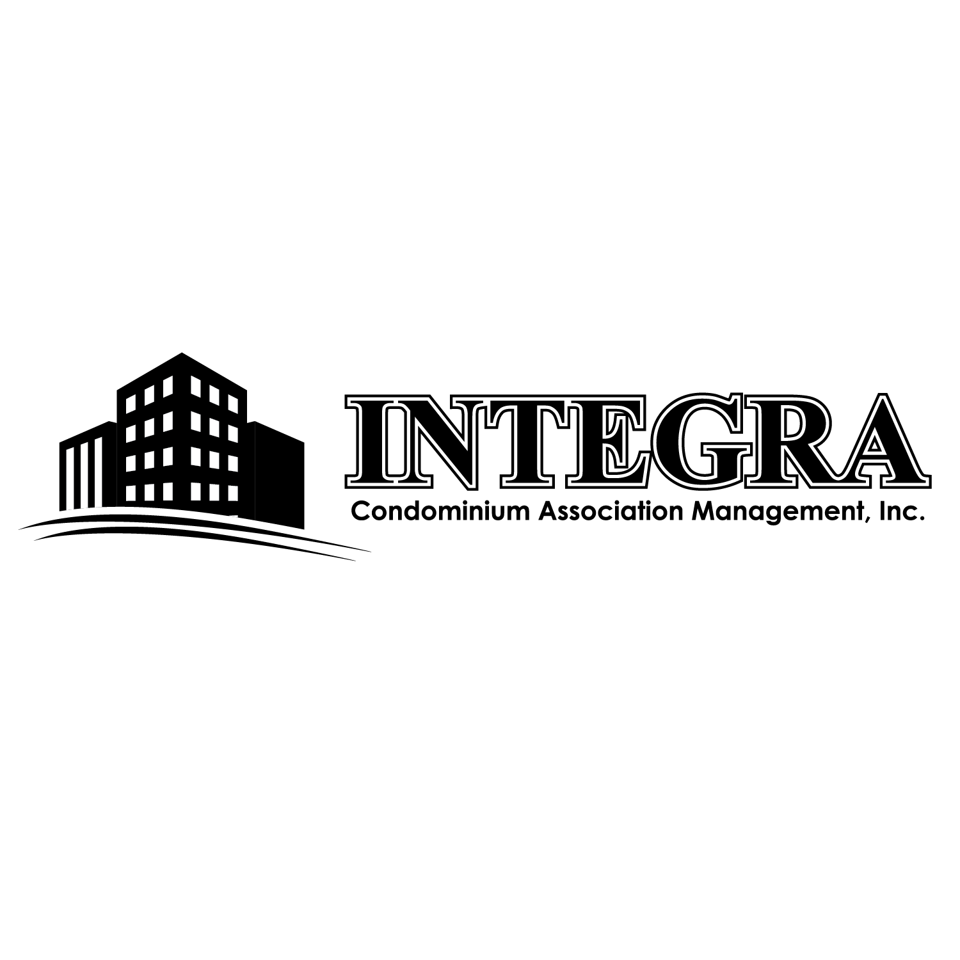

MEMO
DATE: December 9, 2023

TO: All Unit Owners and Residents
Bay Rim Park Condominium Association

FROM: Cindyrae Mehler
Condominium Association Property Manager

RE: WATER SHUT OFF Notice for ALL BUILDINGS on
Thursday, December 14th
___________________________________________________

THIS MEMO is notification by the Board and Management that Birch Bay Water & Sewer District has advised they will be doing scheduled maintenance work on Thursday, December 14th, 2023 from approximately 12:00/noon until 3:00 pm. No water will be available at this time.

Birch Bay Water & Sewer will be swapping out an old meter with a new one. We apologize for any inconvenience you may experience; however, this is a mandatory maintenance upgrade.

Thank you so much for your patience during this maintenance work. If you have any questions, please contact our office at 360-656-5091 or email us at integra@integra2183.com Our regular office hours are Monday – Friday, between 9:00 am and 4:00 pm.

